

**Capstone: Second Mentor Evaluation THE MONEY TREE**

**(A Personal Finance and Investment Application)**

* **Finalized Analysis Model -**

# Use Case diagram(s)

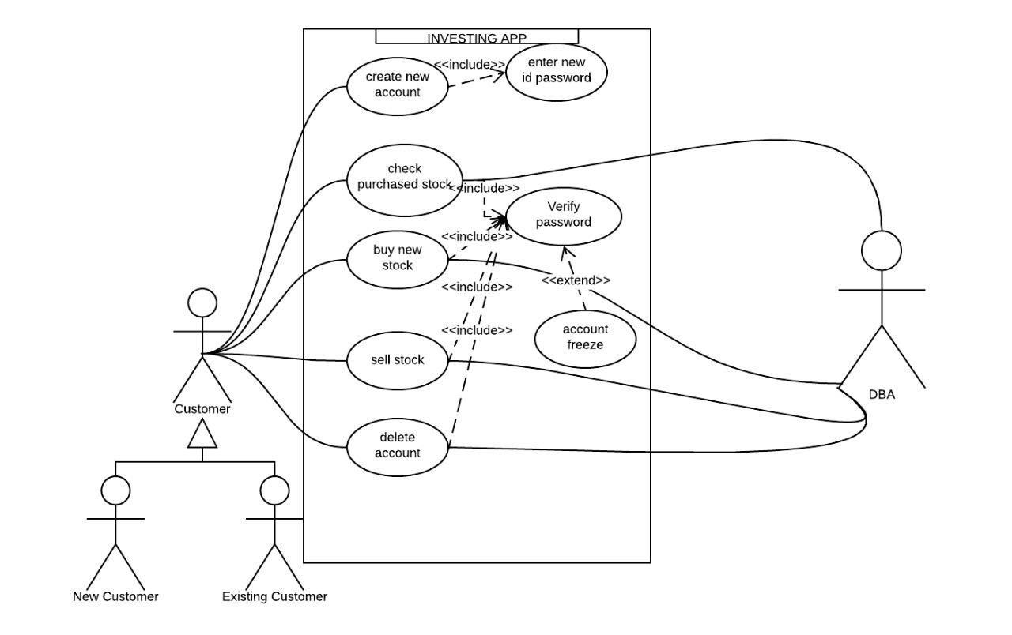

**2. Entity Relationship Diagram**

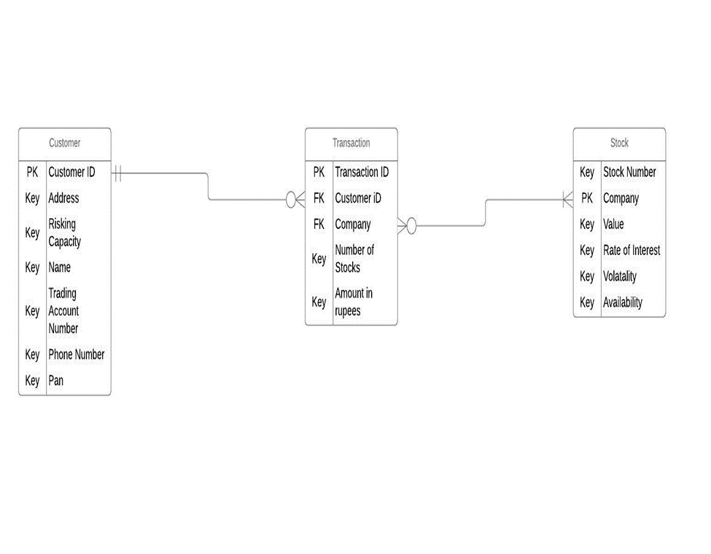

# 3. Class Diagram

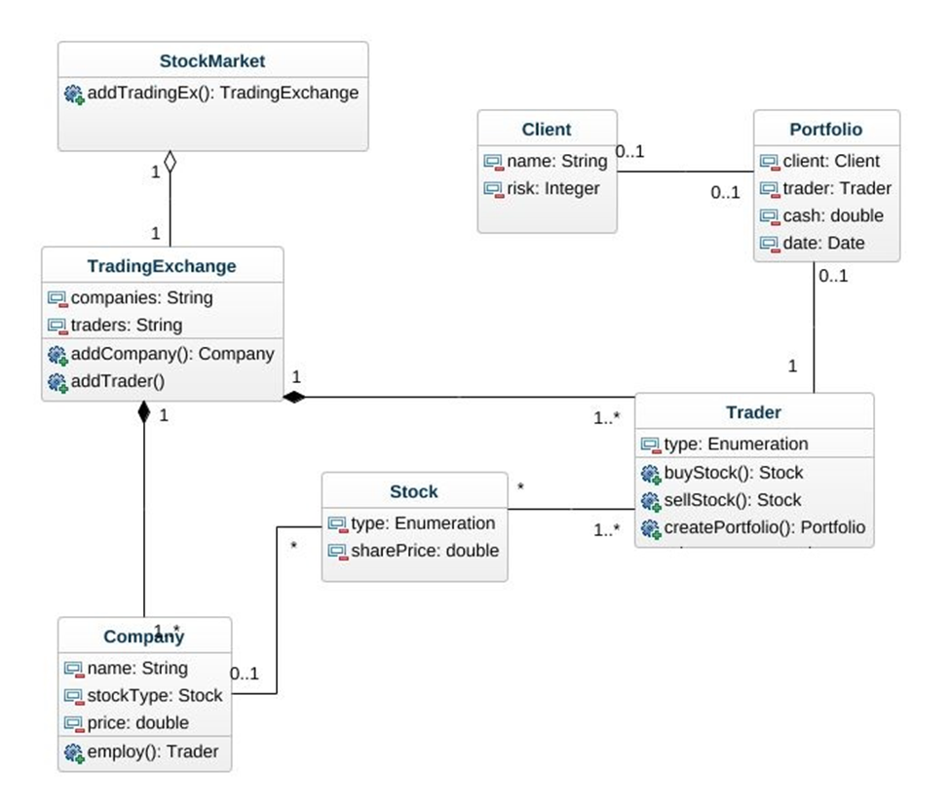

1. **Sequence Diagram**

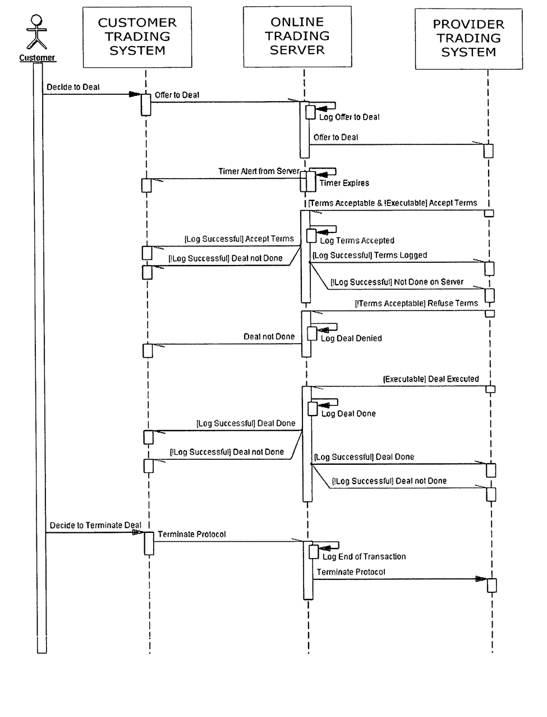

1. **State Chart Diagram**

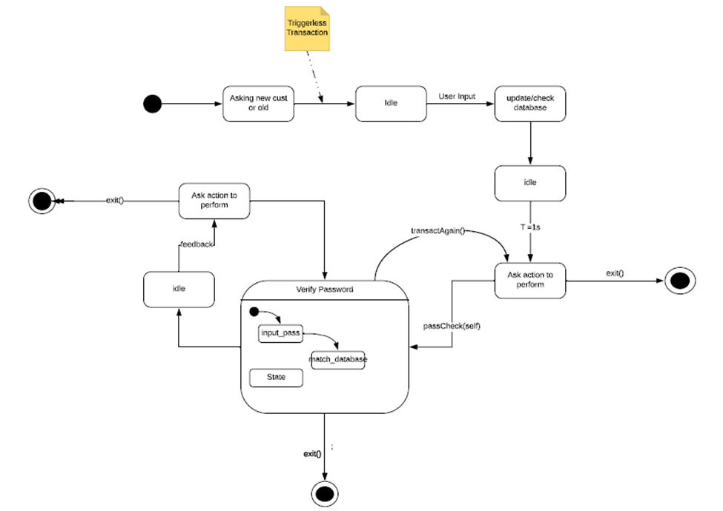

**Cost Analysis -**

|  |  |  |  |  |  |  |  |  |  |  |  |  |
| --- | --- | --- | --- | --- | --- | --- | --- | --- | --- | --- | --- | --- |
| COST STRUCTURE |  |  |  |  |  |  |  |  |  |  |  |  |
| CATEGORIES | MARCH | APRIL | MAY | JUNE | JULY | AUG | SEP | OCT | NOV | DEC | JAN | FEB |
| Domain | 100 | 100 | 100 | 100 | 100 | 100 | 100 | 100 | 100 | 100 | 100 | 100 |
| Hosting | 2500 | 2500 | 2500 | 2500 | 2500 | 2500 | 2500 | 2500 | 2500 | 2500 | 2500 | 2500 |
| Telephone | 500 | 500 | 500 | 500 | 500 | 500 | 500 | 500 | 500 | 500 | 500 | 500 |
| Internet connection | 1000 | 1000 | 1000 | 1000 | 1000 | 1000 | 1000 | 1000 | 1000 | 1000 | 1000 | 1000 |
| Advertising | 5000 | 5000 | 5000 | 5000 | 5000 | 5000 | 5000 | 5000 | 5000 | 5000 | 5000 | 5000 |
| Rent | 10000 | 10000 | 10000 | 10000 | 10000 | 10000 | 10000 | 10000 | 10000 | 10000 | 10000 | 10000 |
| Repair and maintenance | 1000 | 1000 | 1000 | 1000 | 1000 | 1000 | 1000 | 1000 | 1000 | 1000 | 1000 | 1000 |
| TOTAL | 20100 | 20100 | 20100 | 20100 | 20100 | 20100 | 20100 | 20100 | 20100 | 20100 | 20100 | 20100 |
|  |  |  |  |  |  |  |  |  |  |  |  |  |
| TOTAL EXPENSES FOR THE YEAR 2018 | 241200 |  |  |  |  |  |  |  |  |  |  |  |

**Design Model -**

* **Component Design**

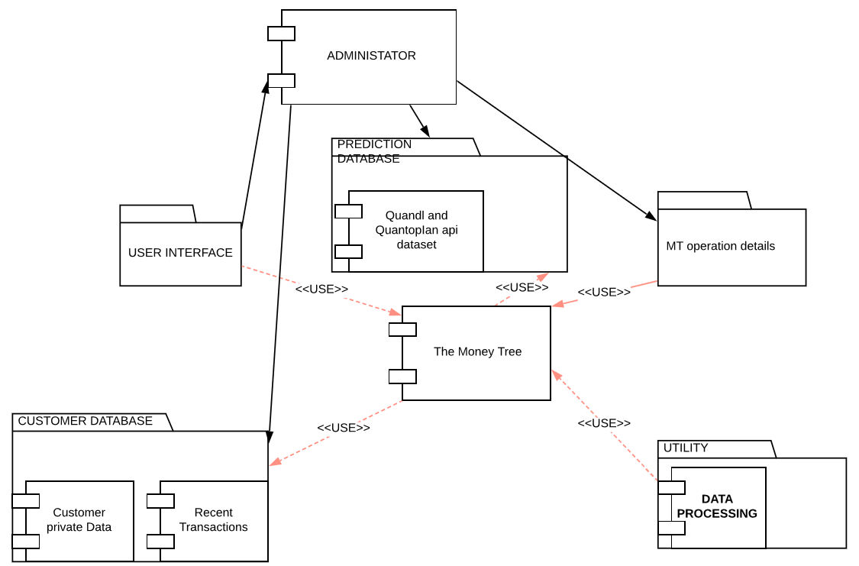

* **Interface Design**

GUI based interface design for easy user interaction

For New User -

* Registration And Login
  + Forgot Password Option
    - Send OTP to User Email Option
  + New User Register Option
    - General Form for New User
* New User Risk Profile Survey Screen
  + Family Linkage Option
    - Find members using user-email and send connect request
  + Current Income Sources
  + Current Investment And Savings Portfolio Add Option
  + Estimated Current Monthly Expenditure
    - Main Sources Selection Option

For General User -

* General Home Screen
  + Family Linkage Option
    - Find members using user-email and send connect request
  + Current Portfolio
    - Current Investment Portfolio Explanation
  + New Expenditure Option
    - Add Expenditure Details like amount, source, re-occurrence
  + Tax Calculation and Recommendation Option
    - Tax Saving Recommendation List
    - Current Payable Tax Status
* Stock Recommendations Screen
  + Stock List Currently Recommended
    - Special Stock Recommendation Option
* Portfolio Screen
  + Current Wealth Distribution

**Architecture Design -**

The system will be built using three tier architecture as the system requires three layers of logical computing namely user interface, Generative query network (application) and database which can be developed independently without any concern about other layers. Three tier architecture provide many benefits for development by separating user interface, main business logic and database. Three tier architecture also allows updation of individual layers without affecting other parts of the system. The three layers will consist of :

* The user interface (presentation layer) will be required to intake user information and provide a basic and easy interface for the user to interact with the system.
* The logic layer (application layer) will consist of powerful algorithms to analyze and evaluate different investment strategies according to personal risk profile.
* The database (data layer) will store basic information about all the users and most of the information will be stored on the user’s device.

